Week 5 – Wednesday Questions

1. List all customers who live in Texas (use JOINs)

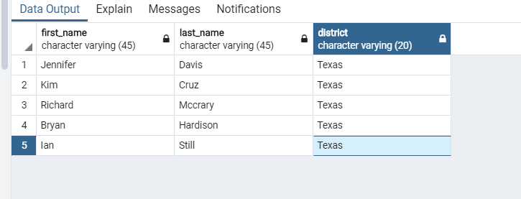

2. Get all payments above $6.99 with the Customer's Full Name

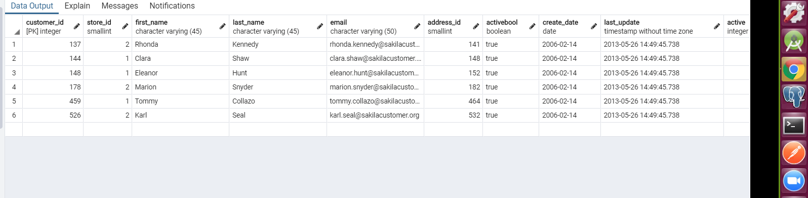

3. Show all customers names who have made payments over $175(use

subqueries)

see SQL

4. List all customers that live in Nepal (use the city

table)

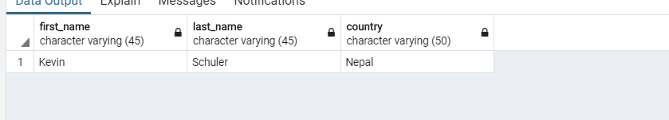

5. Which staff member had the most

transactions?

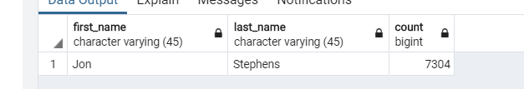

6. How many movies of each rating are

there?

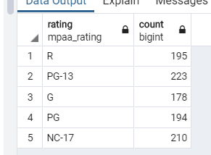

7.Show all customers who have made a single payment

above $6.99 (Use Subqueries)

see SQL too long

8. How many free rentals did our stores give away?

24